Lab Assesment-7

Q)

import java.util.*;

public class Number{

public static void main(String[] args)

{

String reg_no,phone_no;

Scanner sc=new Scanner(System.in);

System.out.println("enter registration number:");

reg_no=sc.nextLine();

System.out.println("enter phone number:");

phone_no=sc.nextLine();

try

{

if(reg_no.length()<9 || reg_no.length()>9)

System.out.println("invalid");

else

System.out.println("valid");

}

catch(IllegalArgumentException e)

{

System.out.println(e);

}

try

{

if(reg_no.length()<10 || reg_no.length()>10)

System.out.println("invalid");

else

System.out.println("valid");

}

catch(NoSuchElementException e)

{

System.out.println(e);

}

finally

{

System.out.println("execution completed");

}

}

}

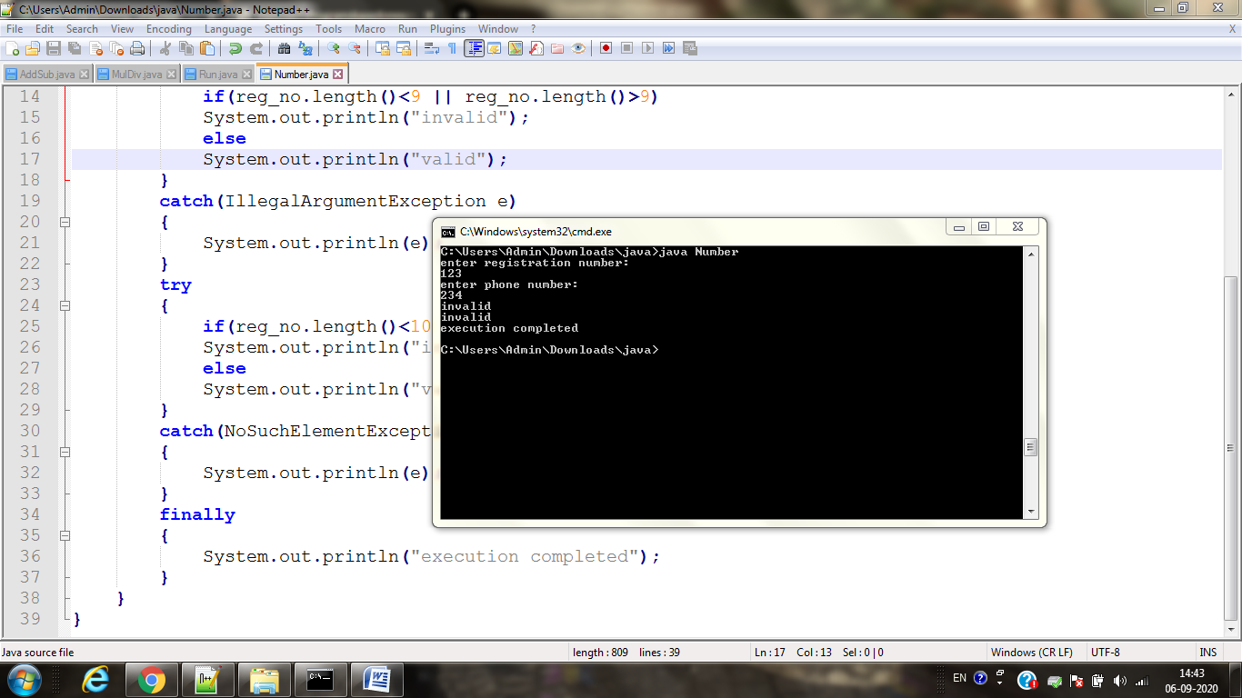

Q)